CSIT314 Software Development Methodologies
Lab 2 - Search User Profiles
User story: As a user admin, I want to search for user profiles so that I can find the group I need to manage.

My assumptions
- The user admin has already logged in.
- A user profile is basically a user group, like "Interior Designer" or "Customer". It has a name, a description, a list of permissions and a status (Active or Suspended).
- The search checks the profile's name and description for the keyword. Capital letters don't matter.
- Suspended profiles still show up in the results (with their status next to them), because the admin might still need to find them.
- Searching doesn't change any data.

1. Use case diagram and use case description
This part is from question 1. I've included it here because the sequence diagram in 2c is based on it.
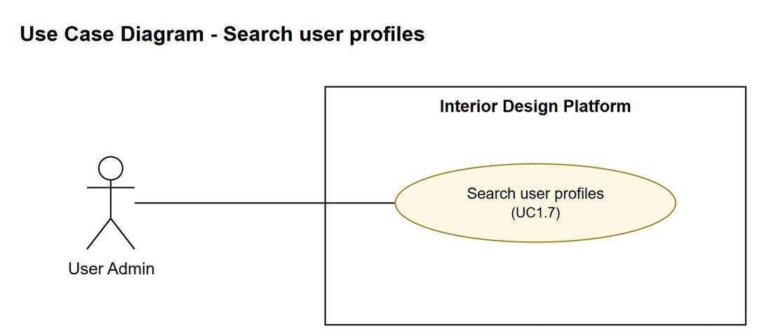
Figure 1: Use case diagram
Use case | UC1.7 Search user profiles
Actor | User admin
User story | As a user admin, I want to search for user profiles so that I can find the group I need to manage.
Preconditions | The user admin is logged in.
Trigger | The user admin types a keyword into the search box on the user profiles page and clicks Search.
Basic flow | 1. The user admin types a keyword (e.g. part of the group's name) and clicks Search.  2. The system looks through all the user profiles for ones that have the keyword in their name or description.  3. The system shows a list of the matching profiles, with each one's name, description and status.  4. The user admin picks the profile they want to manage. From here they can view, update or suspend it, but those are separate use cases.
Alternative flows | 1a. If the keyword is left empty, the system just shows all the user profiles.  3a. If nothing matches, the system shows "No user profiles found" and the user admin can try a different keyword (back to step 1).
Postconditions | Nothing in the system is changed. The user admin has found the profile they were looking for.

2a. Entity classes (attributes, operations and relationships)
Entity classes are the classes that hold the data. Each one is basically a table in the database.
Entity class | Attributes | Operations | What it's for
UserProfile | -profileId: int  -profileName: String  -description: String  -permissions: List<String>  -status: String | +searchUserProfiles(keyword): List<UserProfile> | This is the user group that gets searched. searchUserProfiles() finds all the profiles that match the keyword and returns them as a list.
UserAccount | -userId: int  -username: String  -password: String  -fullName: String  -email: String  -phone: String  -profileId: int  -status: String  -createdDate: Date | (not used in this use case) | Each user account belongs to one user profile. I included it to show the relationship, but this use case doesn't call any of its operations.

Relationship | Multiplicity | What it means
UserProfile to UserAccount (association) | 1 to 0..* | One user profile can have lots of user accounts in it, or none. Each user account is in exactly one profile, which is saved as profileId in UserAccount.

2b. Boundary and controller classes
The lab says to use one controller class per use case, so there's one controller here.
Layer | Class | Operations | What it does
Boundary | SearchUserProfilePage | +searchUserProfiles(keyword)  +displayResults(profiles)  +displayNoResultsMessage() | This is the search page. It gets the keyword from the user admin, then shows either the results or a "No user profiles found" message. The user admin only ever deals with this class.
Control | SearchUserProfileController | +searchUserProfiles(keyword): List<UserProfile> | This is the controller for the Search user profiles use case. It takes the keyword from the page, passes it to UserProfile, and sends the list of matches back to the page.
Entity | UserProfile | +searchUserProfiles(keyword): List<UserProfile> | Finds the saved user profiles that match the keyword.

2d. Class diagram
The solid arrow means the page calls the controller. The dashed arrow means the controller uses the UserProfile entity. The line between UserProfile and UserAccount is the one-to-many relationship.
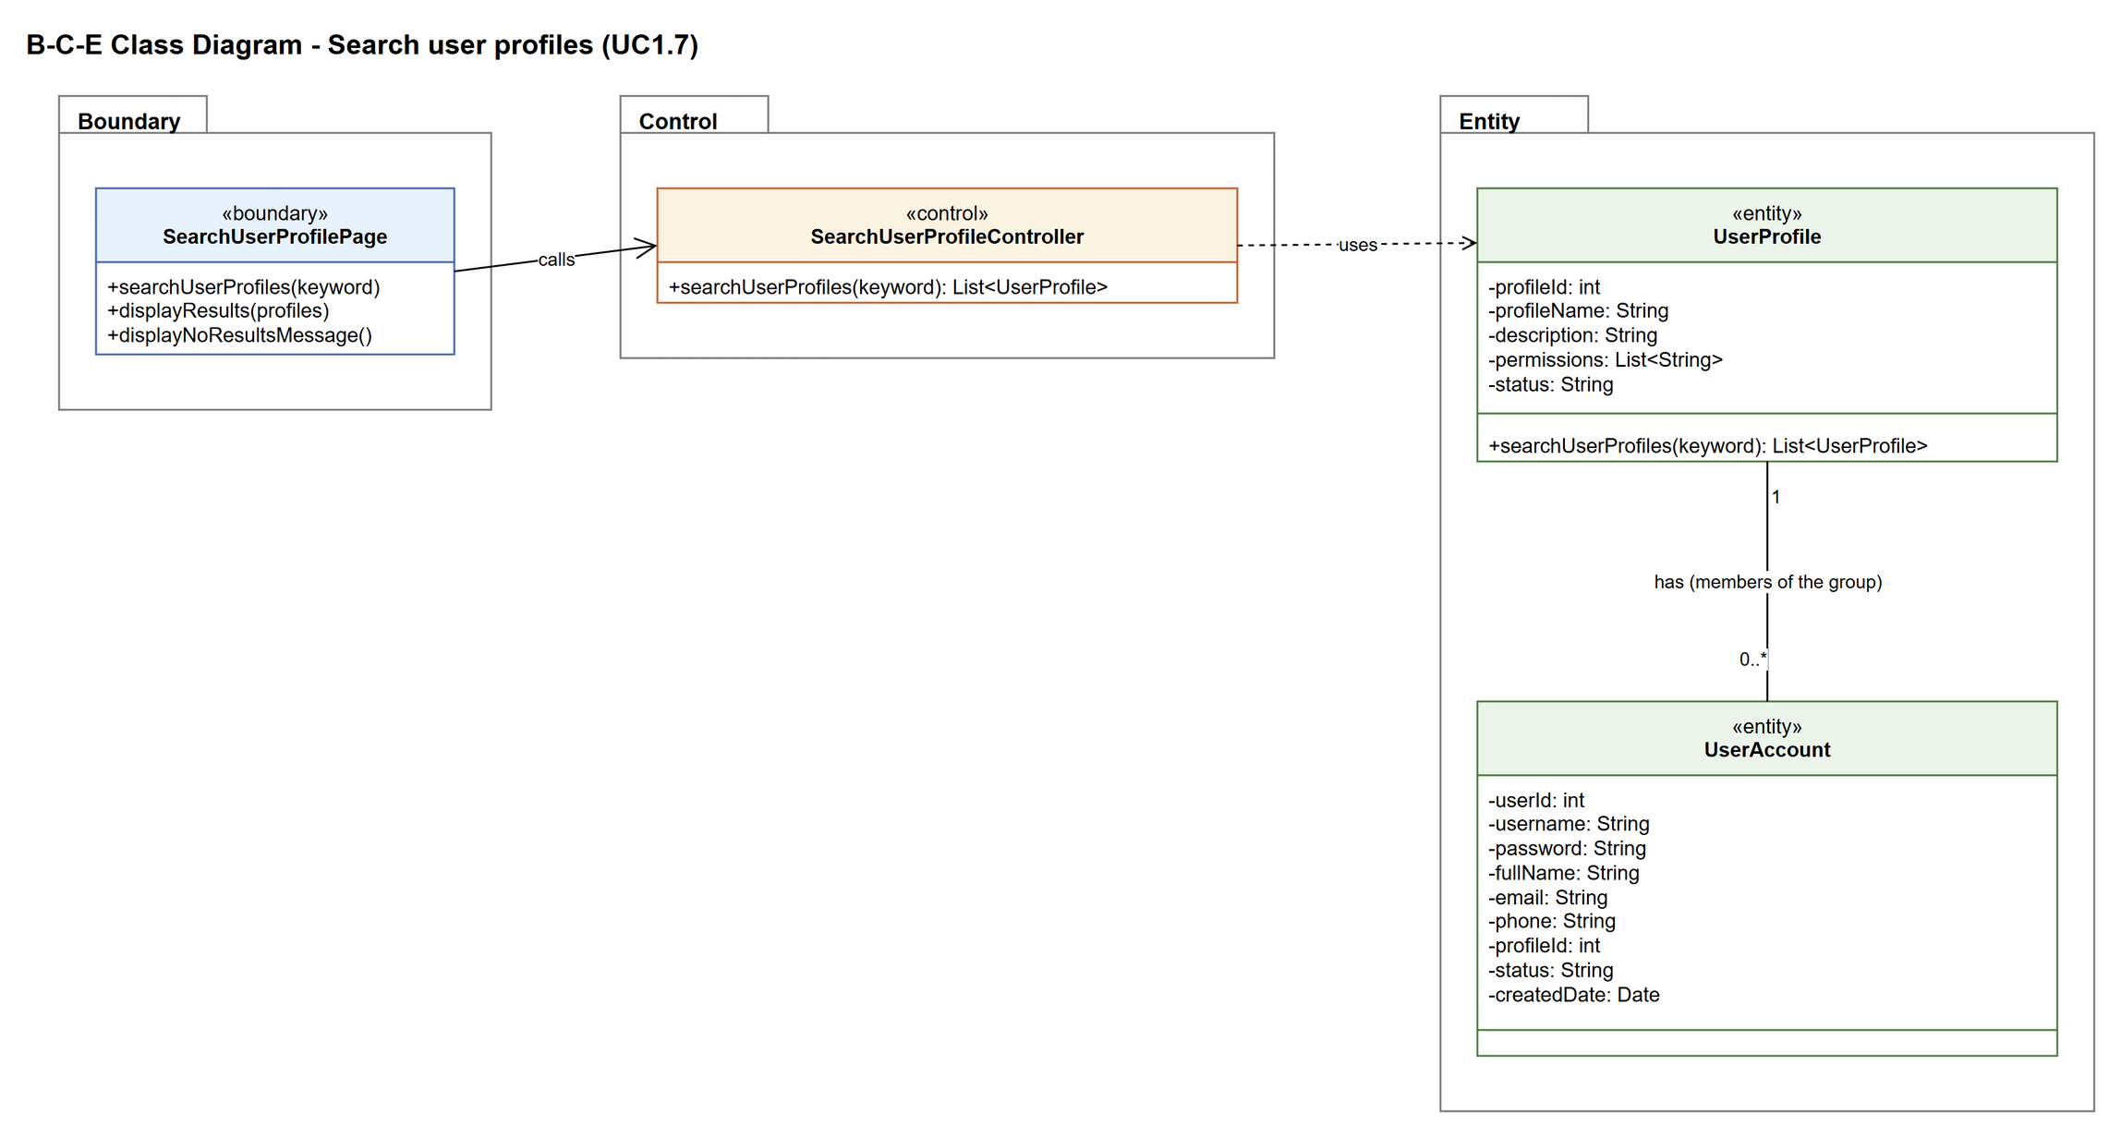
Figure 2: B-C-E class diagram for Search user profiles

2c. Sequence diagram
This sequence diagram follows the use case description in section 1. The alt box shows the two ways it can end: either matching profiles are found and shown (basic flow), or nothing matches and a message is shown instead (alternative flow 3a). Every message in the diagram is an operation from the class diagram.

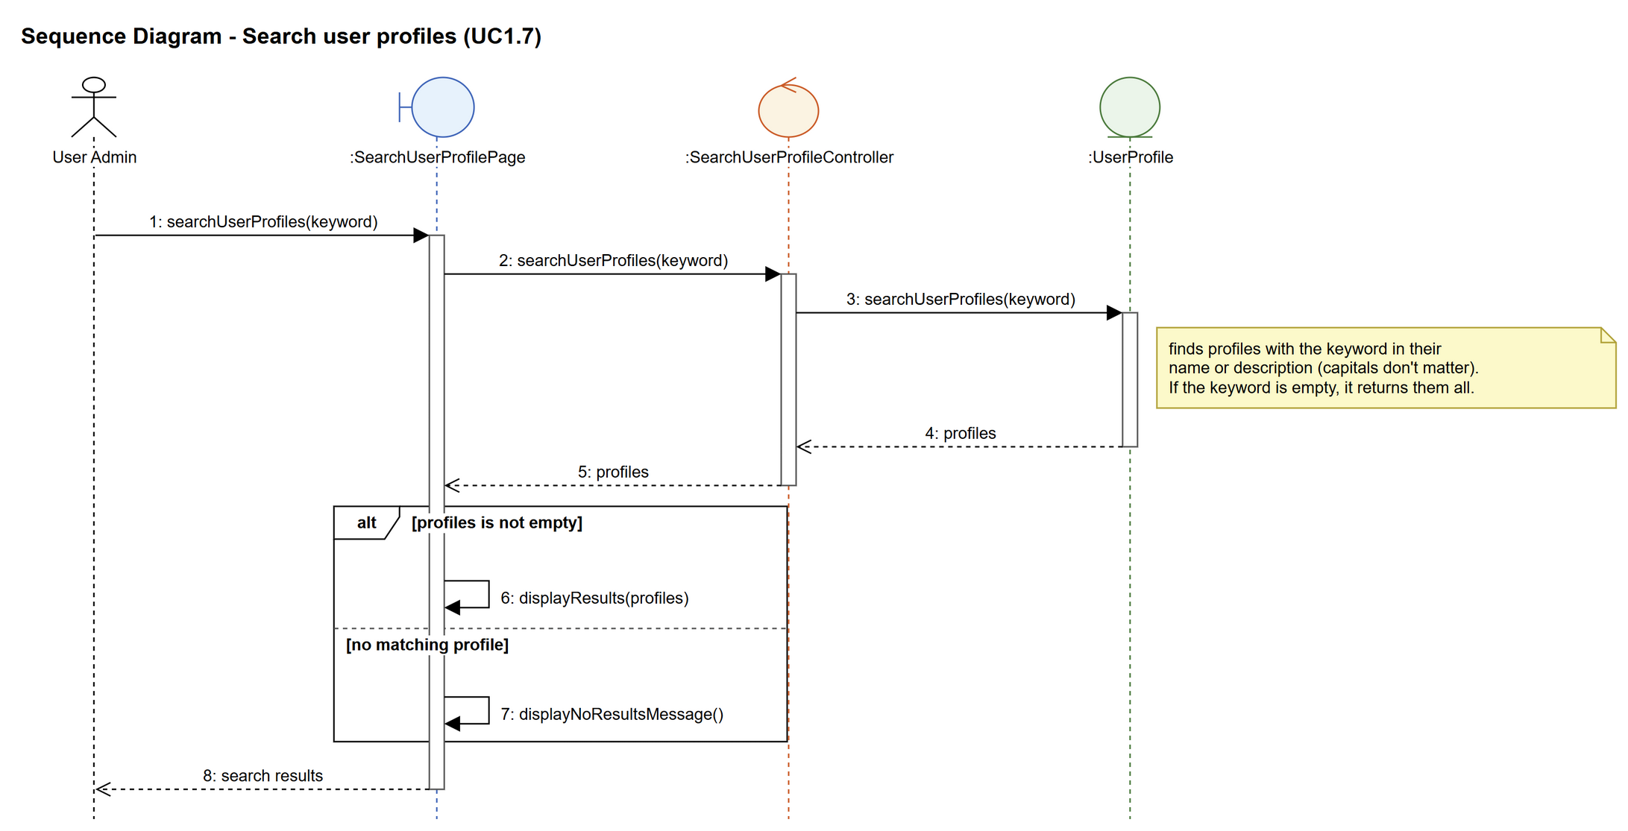
Figure 3: Sequence diagram for UC1.7 Search user profiles

